COMPUTER REPAIR AND MAINTENANCE
0714 351 07A

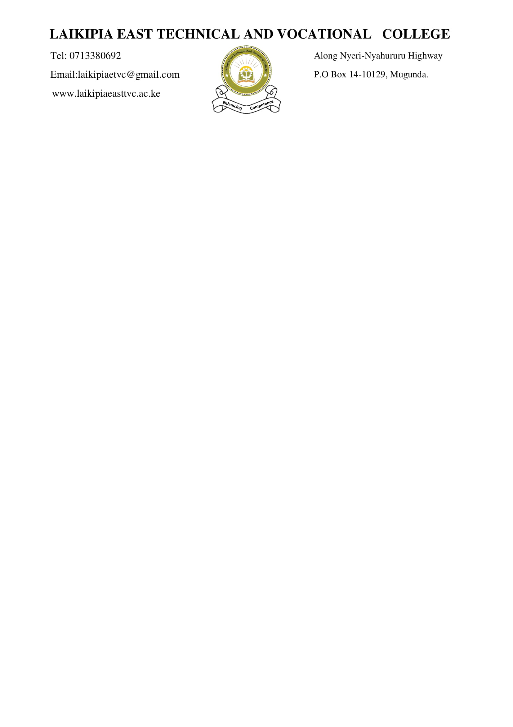
February 2026

PRACTICAL ASSESSMENT

Time: 3 Hours

INSTRUCTIONS TO CANDIDATE
- This paper consists of 2 tasks. Attempt all the tasks.
- Marks for each task are indicated
- You have 10 Minutes to read through, the instructions and check availability of resources for the practical
- Any problem should be reported to the invigilator/supervisor immediately
- The assessor will record your performance at critical points

You are provided with the following resources:
  - Computer
  - Screw driver
  - Blower
  - Anti-Static bags

Questions:

Task 1: Computer Components Identification (20 Marks)
Follow the instructions of the assessor and physically identify at list twenty computer components using the provided resources. Touch each component as you identify it.
Inform the assessor if any component is missing.

Task 1: Computer Disassembly and Assembly (20 Marks)
- Disassemble a computer:
Observe all safety precautions. Disconnect all peripherals and power. Open the system unit and carefully perform the following tasks:
- Remove the hard disk.
- Remove the memory
- Remove the power supply
- Remove the CPU heat sink and fan
- Disconnect the power button connectors
- Disconnect the USB connectors
- Remove any other components attached to the motherboard
- Remove the motherboard.
- Assemble a computer:
Reassemble all the parts you previously removed in Task 1a. Ensure proper connections and placements of each component.
Perform computer components cleaning

